OS SLIP TEST – 01

SCENARIO / CASE STUDY – 6: Running a Shell Script
A system administrator executes:
</> Bash
./backup.sh
The script performs several file operations and creates a backup archive.
6A. 5 Marks
Arrange the major components involved in executing the shell script from the user command to the underlying hardware. Relate each component to the Linux software stack.
6B. 7 Marks
Construct an investigation plan to determine:
- which user-space program interprets the script,
- which system calls are generated during its execution,
- how User Mode and Kernel Mode transitions occur,
- which kernel services handle file and process operations,
- and how system-monitoring tools can be used to trace the script.
6C. 3 Marks
The administrator attempts to execute the script without execute permission. Analyze how Linux file permissions and process-execution mechanisms determine whether the script can be executed.
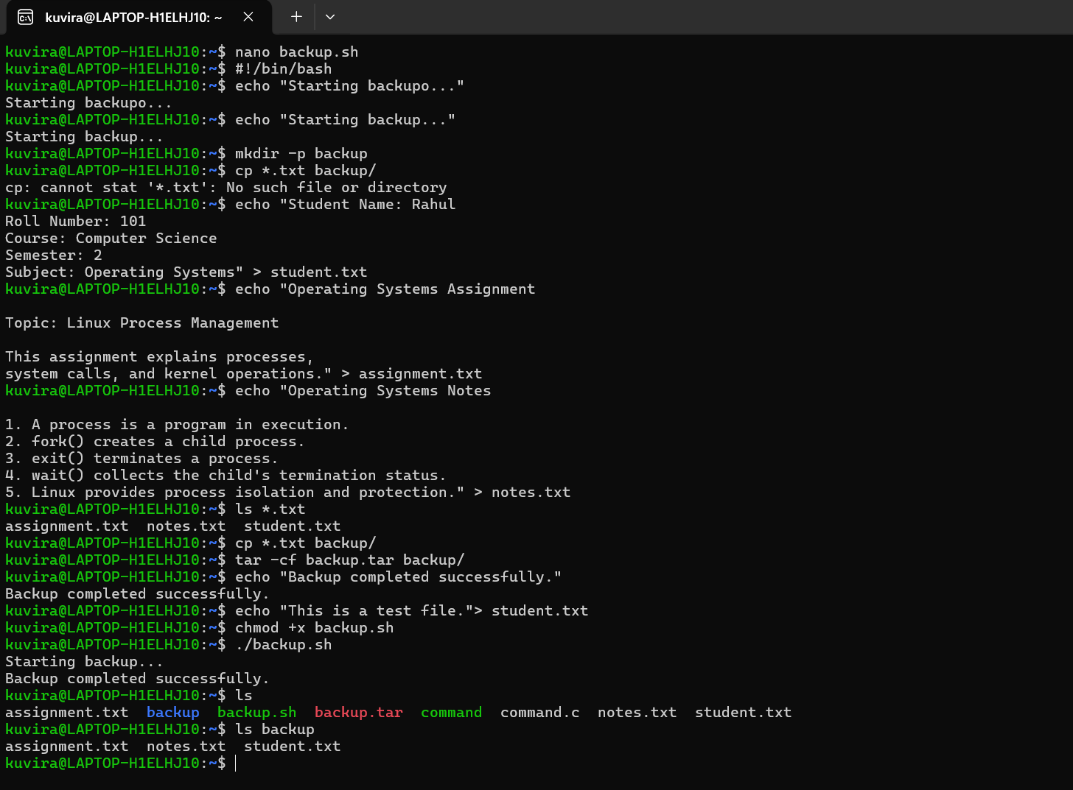

SCENARIO / CASE STUDY – 9: Process Termination
A Linux application completes its execution and invokes:
</> C
exit(0);
The operating system releases the resources associated with the process.
9A. 5 Marks
Arrange the major components involved when a process terminates, beginning with the user-space application and ending with the release of hardware resources. Relate each component to the Linux software stack.
9B. 7 Marks
Construct an investigation plan to identify:
- the user-space program,
- the system call involved in process termination,
- the User Mode–Kernel Mode transition,
- the kernel process-management service involved,
- and the resources released after process termination.
9C. 3 Marks
A parent process terminates without properly collecting the termination status of its child. Analyze how this can result in a zombie process and explain the operating-system mechanism involved.

